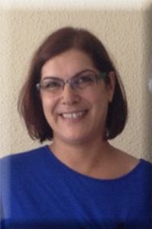
Dr. H. Esen Aşkar GÜRSEL President of GAHEDER
Gaziantep Family Medicine Association Gaziantep, TURKEY

Dear All,
Every year, for the anniversary of birthday of Fredrich BANTIG
who discovered insülin hormone in 1921, leading to treatment of
millions of people who have diabetes; November 14 had
been celebrated as ‘World Diabetes Day’ with various programs.
Since from 1991, being member of International Diabetes
Federation (IDF) more than 150 organisations out of
125 countries contributed to this special day.
Concerns are raising since the increasing prevalance of diabetes as well as its complicatons. In Turkey, estimated number of diabetes population is 2.6 million wheras
2.4 million people stand as diabetes candidates (pre-diabetes, and etc…),
thus in sum; over 5 mllion seem to be affected. Prevalance of diabetes,
eating habits, lack of enough physical actvity in our City, Gaziantep;
provoked us to organise 1st International Diabetes Symposium
mainly focusing on behavioral change and awareness of
this non-communicable disease.
Welcome to the Symposium,

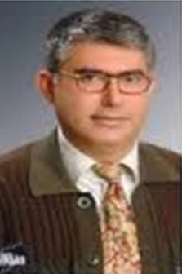
Mehmet Akif BÜYÜKBEŞE, MD
Professor of Internal Medicine
Member of board of trustees of
Turkish Diabetes Foundation
KSU School of Medicine,
Diabetes Research, Education & Management Center Kahramanmaraş, TURKEY

Dear Colleagues,
Today, I am more than happy and proud to have a chance to bring together healthcare professionals of Turkey and international diabetologists who are from the United States (Florida & Illinois), United Kingdom (Cardiff, Leicester) and Australia (Darwin). Without help of Gaziantep Family Medicine Assocation (GAHEDER),and tolerance of our families, this organisation could not happen.
We did try to make this symposium unique by having different disciplines such as bio-engineer, pychologist, family medicine physician, diabetes nurse, dietician and endocrinologist serving for diabetes in different parts of the world. While this elegant speakers are coming and honoring us today, your questions at the end of each session will help enlighhten the points that may in case stand obscure in our daily practice.
Very welcome to 1st International Diabetes Symposium here in Gaziantep, the city origine of pistachios and baklava. Enjoy your stay and please be with us, nextyear.
Sincerely,
Symposium President

08:00-09:00 Registration
09:00-09:05 Winds of Turkish Songs
Guitar by Atıf Büyükbeşe
09:05-09.10 Welcome Ceremony
Dr. Esen Aşkar Gürsel
Gaziantep Family Medicine Association (GAHEDER)
09:10-09:15 Introduction
Prof Dr Mehmet Akif Büyükbeşe
President of Symposium
09:15-09:45 Chair: Prof. Dr. Mehmet Akif Büyükbeşe
KSU School of Medicine, Diabetes Research & Education Center,
Kahramanmaraş, TURKEY
A. Michael Albisser, PhD, Emeritus Professor of Medicine
Villages, Florida, USA
Bioengineering in Diabetes and How Virtualized
Telemedicine Works for Achieving & Maintaining Perfect
Diabetes Control
09:45-10:00 Questions & Answers
10:00-10:30 Chair: Assoc. Prof. Dr. Taner Bayraktaroğlu,
Bülent Ecevit University, Endocrinology,
Zonguldak, West Black Sea Area
Prof. Dr. Mehmet Akif Büyükbeşe
Member of Board of Trustees of Turkish Diabetes Foundation
KSU School of Medicine, Diabetes Research,
Education & Management Center,
Kahramanmaras, TURKEY
Diabetes in Turkey: Presidency of Turkey Diabetes Peer
Project & Other Awareness Programs
10:30-10:45 Questions & Answers
10:45-11:15 Coffee & Tea Break
11:15-11:45 Chair: Assist. Prof. Dr. Halil K. Erol
Diabetes and Obesity Center, Fatih University, Istanbul
Co-Chair: Mustafa Çevik MD
GUSAF Presedıent
(President of Southeast International Health Federation of TURKEY)
Dr. Mohamed Hassanein
FRCP (London), FRCP (Edinburgh),
Consultant Diabetes & Endocrinology, BCUHB Wales,
Associate Director, Postgraduate Diabetes Education,
Cardiff University, UK
What happens in Ramadan for
People with Diabetes who Fast? DAR Project
11:45-12:00 Questions & Answers
12:00-13:00 Lunch & Refreshments

13:00-13:30 Chair: Prof. Dr. Aytekin Oğuz
Head of Internal Medicine Department, Medeniyet University, Istanbul
President of Turkish Metabolic Syndrome Association
Professor Azhar Farooqi OBE FRCGP
General Practitioner East Leicester Medical Practice,
Leicester, UK
GP System in UK and Role of general practioners for
diabetes management.
13:30-13:45 Questions & Answers
13:45-14:15 Chair: Assoc. Prof. Dr. Cumali Gökçe
Mustafa Kemal University, Endocrinology Department, Hatay, TURKEY
Co-Chair: Assist. Prof. Dr. Mehtap Omaç Sönmez
KSU, Health Science Center, Head of Nursery Department,
Kahramanmaraş, TURKEY
Heather Daly
Consultant Nurse, Leicester General Hospital, Leicester, UK
Role of Diabetes Nurse in the Diabetes Team
14:15-14:30 Questions & Answers
14:30-15:00 Coffee & Tea Break
15:00-15:30 Chair: Prof. Dr. Mehmet Akif Büyükbeşe
KSU School of Medicine, Department of Internal Medicine,
Kahramanmaraş, TURKEY
Barbara Eichorst, MS, RD, CDE
Healthy Interactions,
Chicago, Illinois, USA
Diabetes Self-Management Education and Support
(DSME/S): What is it, How it works, Who provides it, and
What are its outcomes? – USA perspective
15:30-15:45 Questions & Answers
15.45-16:15 Chair: Bülent S. Cansunar, MD, Medical Director
Şehitkamil Hastanesi (State Hospital), Gaziantep, Turkey
Timothy Charles Skinner
Head of School of Psychological and Clinical Sciences
Faculty of Engineering, Health, Science & the Environment
Charles Darwin University,Darwin, Australia
Diabetes Psychology
16:15-16:30 Questions & Answers
16:30-16:45 Closing Remarks
Prof. Dr. Mehmet Akif Büyükbeşe
Member of Board of Trustees of Turkish Diabetes Foundation
KSU School of Medicine, Diabetes Research & Education Center,
Kahramanmaraş, TURKEY

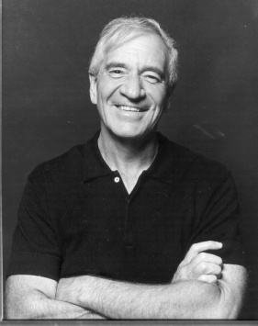
A Michael ALBISSER, PhD
Emeritus Professor of Medicine Acting Director,
Center for Perfect Diabetes Control The Villages, Florida, USA
Batchelor degree in Elecrical Engineering from McGill University. His post-graduate studies were at the University of Toronto where he received both an M.A.Sc. degree and a Ph.D. in Biomedical Engineering.
He pioneered the world’s first clinical artificial endocrine pancreas and intravenous insulin delivery systems. Emphasis was on advanced algorithms for technology assisted diabetes management and self-care. Basic research has focused on clinical metabolism, mathematical modeling, computer simulation and biological control. He has been awarded numerous Federal Research Grants and has held several NIH Small Business Innovation Research Grants focused on the development of information technology for disease management.
Received the European AILD award “for the major contribution of his original and outstanding research in the advancement of knowledge in the field of diabetes during the last four decades”. Published over 125 articles in peer reviewed journals, over 22 invited articles, and over 35 book chapters.
Speaker with more than 150 invited distinguished lectures and visiting professorships. He has several patents on inventions world-wide.

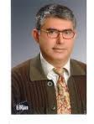
Mehmet Akif BÜYÜKBEŞE, MD
Professor of Internal Medicine
Member of board of trustees of
Turkish Diabetes Foundation
KSU School of Medicine,
Diabetes Research & Education Center Kahramanmaraş, TURKEY

Both MD & internal medicine residency degrees from Istanbul University where he’d started focusing on diabetes subject. Founded internal medicine department at KSU School of Medicine in Kahramanmaras and served as a head for 6 years. Board certified in internal medicine.

Several diabetes management and research experiences in the USA: Albert Einstein College of Medicine, Bronx, NY, MD Anderson Cancer Center & Univ TX Houston Diabetes and Endocrinology Program, Indian Medical Health Center, NIH, Diabetes Outpatient Clinic (Phoenix). Worked as a postdoctoral research fellow in UK (Univ. of Leicester, Clinical Diabetes Research Centre) and Kronos Longevity Research Institute, Phoenix, Arizona, USA. Holds an ECFMG certificate (2008). Gave diabetes lectures in GoettingenUniv-Germany through ERASMUS Programme.

Members of International Diabetes Foundation (IDF), Trustees of Turkish Diabetes Foundation, European Society of Cardiology, Turkish Society of Metabolic Syndrome, Internal Medicine Society of Turkey. Served for Southeastearn Anatolia Diabetes Project for 6 years and now, the Kahramanmaras City Coordinator of ‘Presidency of Turkey Diabetes-Peer’ Project. Carrying on his diabetes patient and family medicine physician (gp) education programs as well as phase 3 and phase 4 diabetes drug clinical studies.

More than a 100 publications both in Turkish and English in internal medicine area mostly in diabetes. In the editorial board of Journal of Clinical Medicine and Research, and reviewer of Science Alert, European Journal of Genreral Medicine, Balkan Medical Journal (SCI-Exp), Diabetes Forum (Turkish), Diabetes Science and Endocrinology (Turkish), Glance at Diabetes (Turkish), Turkey Clinics Medical Science, Dialogue in Endocrinology (Turkish),..etc

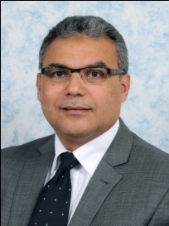
Dr Mohamed M HASSANEIN
MB CHB, FRCP (Lon), FRCP (Edin), Mphil Consultant Diabetes & Endocrinology,
Betsi Cadwaladr University Health Board
Glan Clwyd Hospital, N Wales,
UK Honorary Senior Lecturer & Associate Director for Postgraduate Diabetes Education,
Cardiff University, UK

Dr Hassanein has been appointed in his current post in 2002 and he’s currently his hospital lead physician in Diabetes & Endocrinology.
He has helped in developing the Wales Diabetes Guidelines. His research interest is in the field of Diabetes and Ramadan where he was a co-author in the ADA recommendations for 2005 & 2010. He was also a co-author for the British recommendations published in the BMJ 2010. He has been part of numerous studies and publications in this field and he’s a co-recipient for the Diabetes-UK structured education first prize in 2008 & 2009 as well as the European Association for the Study of Diabetes (EASD) education prize in 2009.
He has developed 2 educational programs for Diabetes and Ramadan in collaboration one in UK with Leicester University and another Internationally in Arabic language. Dr Hassanein is also a co-founder and the Associate Director of the Cardiff University Diabetes Diploma and he is active in numerous national and international educational activities. He’s also an examiner with the Royal College of Physicians for the MRCP clinical exam.

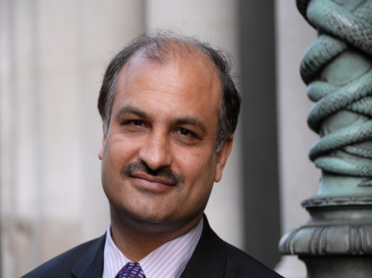

Professor Azhar FAROOQI
OBE FRCGP General Practitioner
East Leicester Medical Practice
131 Uppingham Road, Leicester, UK

GP at the East Leicester Medical Practice since 1987.
Elected a Fellow of the Royal College of General Practitioners (RCGP).
Main research interests are in diabetes and ethnic minority health issues. Published over 80 peer reviewed papers as well as several book chapters.
Co-chair of the Leicestershire and Northamptonshire Comprehensive Research Network and chair of Leicester City Clinical Commissioning Group.
His national work has included advisory work for Diabetes UK, the British Heart Foundation and the Department of Health -including helping to develop the Diabetes NSF.

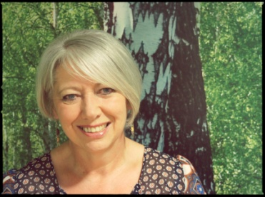
Heather DALY
Nurse Consultant Diabetes Research
Leicester Diabetes Centre – Air
Leicester General Hospital
Leicester, UK
I have worked as a Nurse Consultant at the University of Leicester for past 10 years, working collaboratively with primary care trusts to improve diabetes services across Leicestershire. The last 28 years of my nursing career have been spent working in the field of Diabetes. Provisionally in Nottingham and Derby, and now in Leicester. In my clinical role as consultant nurse I established the Leicestershire diabetes website and guidelines for care. www.leicestershirediabetes.org.uk
More recently I moved into a Nurse Consultant role in collaborative leadership in Applied Health Research and Care. My role is one of leadership, vision and strategic management and I lead a diverse team of healthcare professionals and researchers from a variety of backgrounds. My research interests are in gaining research funds to develop and test structured education programmes which support self-management in people with diabetes, in the prevention of diabetes in those at risk, people with diabetes and learning disabilities and for women with polycystic ovary syndrome (PCOS). I am currently working on programmes to address vascular risk such as heart disease and stroke, sleep apnoea and mental health. This includes the training and quality developments of healthcare professionals delivering these interventions. I have a national profile for the DESMOND programme and I am a national expert trainer for ‘Conversation Maps’. I have enjoyed being instrumental in developing and establishing the nationally recognised Diabetes Masters Programme with the University of Leicester and have a keen interest in healthcare professional (HCP) education to improve standards of care for people with diabetes.
Leicester has a large south Asian community and I have led several initiatives both clinical and research to meet their specific needs. For example a toolkit of education to support people with diabetes to remain safe when fasting during Ramadan, an interactive DVD to address the barriers to injectable therapies in this group of people and their carers and training to increase cultural awareness amongst HCP’s
In April 2012 I was instrumental in obtaining a grant of 1 million pounds of transformation funding to redesign diabetes services across Leicestershire and Rutland which includes developing the patient pathway and describing the models required for effective structured patient education across that pathway.
The delivery of high quality care is dependant on a competent and skilled workforce and I have collaborated with the Leicester City CCG and obtained £900,000 of funding over 3 years to establish an approach to health care professional training that is both bespoke and flexible to meet the needs of their workforce. I lead a team of individuals to deliver this initiative.
In 2012, I was awarded the QIC Diabetes outstanding educator in diabetes award and more recently the named Janet Kinson lecture to be delivered at the 2014 Diabetes UK annual conference in recognition of my contribution to diabetes care.
Underpinning all of these patient and HCP programmes, my philosophy has always reflected and person centred approach to self management
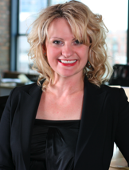
Barbara EICHORST, MS, RD, CDE
Healthy InteractionsChicago, Illinois, USA

A dietitian & certified diabetes educator. Currently leading the development and implementation of the global training for the diabetes franchise. As an educator with experience in medical continued education and patient interventions, contributed to much of the advancement in diabetes care.
Most recently, she was a Chicago based insulin education specialist and a medical liaison for the USA initiative. Her professional experience includes work at American Association of Diabetes Educators as a program director. Also, at the Chicago based Rush University Medical Center, she was a diabetes program manager. Provided patient education in diabetes, weight management, cardiovascular disease among many other chronic conditions at Loyola University Medical Center and Northwestern Memorial Hospital. Barbara’s professional focus is on behavioural interventions in disease management.
Contributed to multiple publications and textbooks with her expertise in diabetes care and behaviour change.
Barbara's favorite personal activities include playing with dogs, movies, dining out, working out, fashion shopping and just relaxing doing nothing.

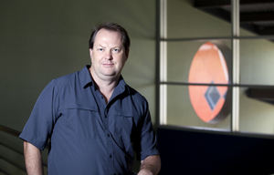
Prof Timothy Charles SKINNER
Head of School
School of Psychological and Clinical Sciences
Faculty of engineering, health, science and the environment
Charles Darwin University
Darwin, Northern Territory, AUSTRALIA

Professor Skinner worked as a clinical director and researcher as well as lecturer in various universities in Australia. Before he was a health psychologist in Leicester Uniersity, United Kingdom. He was a research fellow at University College London and a graduate fellow from University of Surrey which are both in UK. He was a chief investigator of many topics on pyschological aspects which are metabolic control and well-being in teenagers with insulin-dependent diabetes mellitus, development of an educational module for use in ethnic minority patients newly diagnosed with type 2 diabetes: a project building on the Diabetes Education and Self Management for Ongoing and Newly Diagnosed (DESMOND) programme, etc. He received aboriginal grants when he moved to Australia from UK.
He has a more than a 100 peer-reviewed article. One of them was a comparison between UK and Turkey on attitudes of healhcare professionals regarding insulin use in patients with type 2 diabetes:
Thaware PK, Buyukbese MA,Skinner TC, Traingham JR, Jarvis J, Davies MJ. Tip2 Diyabet Hastalarinda insulin Tedavisine Baslama Konusunda Saglik Calisanlarinin Tutumu. Diyabet Forumu 2006; 3(4):41-48.
He is an associate editor of ‘Diabetic Medicine’ and co-editor of‘Australasian Region: Rural and Remote Health’.
Reviewer of Diabetic Medicine, Diabetes Care, Diabetologia, Diabetes Metabolism: Research and Reviews, Practical Diabetes International. Received lately, 2012 Scholarship from University of Melbourne for MTEM course.

