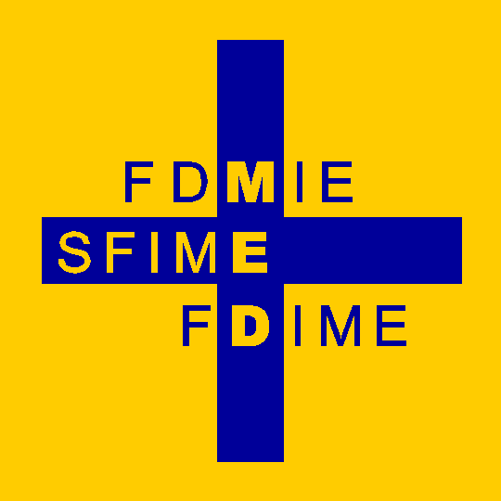 | The Foundation for the Development of Internal Medicine in Europe  and  The European Federation of Internal Medicine | 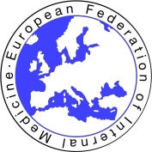

FDIME-EFIM 13th CLINICAL RESEARCH SEMINAR

Paris, 3 – 5 July 2017
Supported by


The 13th FDIME-EFIM Clinical Research Seminar will take place in Paris from 3 - 5 July 2017. Residents to arrive Sunday 2 July.
The Foundation (FDIME) will provide funding for Travel and Accommodation (3 nights in Paris) for up to 17 selected candidates who wish to develop their existing clinical research skills.
For full details, view the Announcement, Seminar Schedule and Application form on the Online Application page: www.fdimeapply.co.uk
Upload your current CV with your online application.
For any additional enquiries contact Janet Stevens, FDIME Administrator at: contact@fdime.org
The closing date is: 30.04.2017.

